|  |  |
| --- | --- |
|  | **GrocerEase**  **An Innovative Online Grocery Shopping Platform**  **(Technical Design Document)** |
| |  |  |  |  | | --- | --- | --- | --- | |  | **Prepared By / Last Updated By** | **Reviewed By** | **Approved By** | | **Name** | Puneet Vashistha |  |  | | **Role** | Programmer Analyst Trainee |  |  | | **Signature** |  |  |  | | **Date** |  |  |  | |
|  |

Table of Contents

1.0 Introduction 3

1.1 Purpose of this document 3

1.2 Project overview 3

2.0 Solution Summary 3

2.1 Scope 3

2.2 Assumptions 3

2.3 Dependencies 3

2.4 Risks 3

3.0 Schematic Diagram 3

4.0 System Design 4

4.1 Proposed design 4

4.2 Component inventory 4

5.0 Database Design 4

5.1 Data Model 4

5.2 Tables Structure 4

6.0 Appendices 4

6.1 Glossary 4

6.2 Other 5

7.0 Terms & Conditions 5

8.0 Change Log 5

# Introduction

## Purpose of this document

**GrocerEase** is an ambitious project aimed at revolutionizing the way people shop for groceries online. This platform caters to both customers and administrators, providing a seamless experience for all stakeholders.

## Challenges Faced by Online Grocery Stores

1. **Inventory Management and Freshness:**
   * Ensuring consistent quality and freshness of perishable items is a significant challenge.
   * Managing stock levels, minimizing wastage, and maintaining accurate inventory records are crucial.
   * **Solution:** Real-time inventory tracking systems and efficient supply chain management.
2. **Delivery Logistics:**
   * Timely delivery is critical for customer satisfaction.
   * Coordinating delivery personnel, optimizing routes, and handling last-mile challenges pose difficulties.
   * **Solution:** Real-time tracking, and reliable delivery partners.
3. **User Experience and Usability:**
   * Online grocery platforms must be user-friendly.
   * Navigating through product categories, searching for items, and seamless checkout are essential.
   * **Solution:** Responsive web design, intuitive interfaces, and efficient search functionalities.
4. **Quality Assurance:**
   * Customers expect the same quality as they would find in physical stores.
   * Ensuring accurate product descriptions, high-resolution images, and reliable reviews is crucial.
   * **Solution:** Rigorous quality checks, and transparent contact communication.

## Project overview

GrocerEase is a pioneering online grocery shopping platform that aims to redefine the way consumers shop for groceries. The project will focus on developing a platform that caters to both customers and administrators, ensuring a seamless experience for all stakeholders. The platform will address key challenges in the online grocery sector, including inventory management, delivery logistics, user experience, quality assurance, security, and payment gateways. It will offer a range of features such as product and category management, delivery status tracking, user registration, browsing and shopping, seamless checkout, and surprise digital gifts.

# Solution Summary

## Scope

The scope of the GrocerEase project encompasses the following:

1. **Platform Development**: Design and develop an online grocery shopping platform that caters to both customers and administrators. The platform will be user-friendly, scalable, and secure.
2. **Inventory Management**: Implement real-time inventory tracking systems to ensure the quality and freshness of perishable items, manage stock levels, minimize wastage, and maintain accurate inventory records.
3. **Delivery Logistics**: Develop a system for coordinating delivery personnel, and handling last-mile challenges. This includes real-time tracking and integration with reliable delivery partners.
4. **User Experience Enhancement**: Design a responsive and intuitive interface with efficient search functionalities to improve the user experience. This includes seamless navigation through product categories and a smooth checkout process.
5. **Quality Assurance**: Ensure accurate product descriptions, high-resolution images, and reliable reviews through rigorous quality checks and transparent customer communication.

The project’s success will be measured by its ability to effectively address the challenges faced by online grocery stores and enhance the shopping experience for all stakeholders.

## Assumptions

1. **Market Demand**: There is a significant demand for online grocery shopping platforms, and this demand will continue to grow in the foreseeable future.
2. **Technology Availability**: The necessary technology and infrastructure to develop and maintain an online grocery shopping platform are readily available and accessible.
3. **Supplier Reliability**: Suppliers will provide consistent quality and freshness of perishable items, and they will be able to meet the demand.
4. **Delivery Logistics**: Reliable delivery partners are available and can ensure timely delivery of groceries.
5. **User Adoption**: Users, both customers and administrators, will adopt and adapt to the new platform quickly.

## Dependencies

1. **JAVA Spring Boot:**
   * A powerful Java-based framework for building robust, scalable, and efficient web applications.
   * Spring Boot simplifies development, enhances productivity, and provides essential features out of the box.
   * **Used for:** Backend development, business logic, and RESTful APIs.
2. **Hibernate:**
   * An Object-Relational Mapping (ORM) framework that bridges the gap between Java objects and relational databases.
   * Simplifies database interactions, handles data persistence, and ensures efficient queries.
   * **Used for:** Data access layer, interacting with the MySQL database.
3. **MySQL:**
   * A popular open-source relational database management system.
   * Stores product information, user profiles, order history, and other essential data.
   * **Used for:** Storing and retrieving data efficiently.
4. **HTML, CSS, and Bootstrap:**
   * HTML (Hypertext Markup Language) and CSS (Cascading Style Sheets) create the structure and style of web pages.
   * Bootstrap, a front-end framework, provides responsive design components and pre-styled elements.
   * **Used for:** Creating user interfaces, responsive layouts, and consistent styling.
5. **JavaScript (JS):**
   * A versatile scripting language used for enhancing interactivity on web pages.
   * Enables dynamic features like real-time search, cart updates, and form validation.
   * **Used for:** Front-end interactions, client-side scripting.

## Risks

1. **Market Volatility**: Changes in market trends or consumer behavior could affect the demand for online grocery shopping.
2. **Technological Challenges**: There could be unforeseen technical issues during the development and maintenance of the platform.
3. **Supplier Inconsistency**: Suppliers may fail to provide consistent quality and freshness of perishable items, or they may not be able to meet the demand.
4. **Delivery Delays**: There could be delays or issues with the delivery logistics, affecting customer satisfaction.
5. **Slow User Adoption**: Users, both customers and administrators, may take longer than expected to adopt and adapt to the new platform.
6. **Security Breaches**: Despite robust security measures, there is always a risk of data breaches and cyber threats.
7. **Payment Gateway Failures**: There could be issues with the payment gateway integration, affecting transaction processes.

# Schematic Diagram

A schematic, or schematic diagram, is a representation of the elements of a [system](https://en.wikipedia.org/wiki/System) using abstract, graphic [symbols](https://en.wikipedia.org/wiki/Symbol) rather than realistic pictures. It gives an overview of overall system

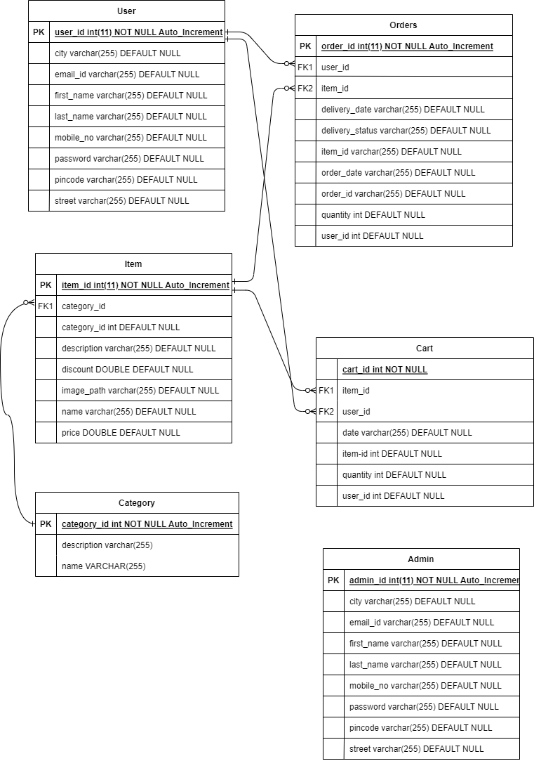

# System Design

## Proposed design

### Key Features and Functionalities

1. **User Stories:**
   * **Admin Side:**
     + **Product and Category Management:**
       - Administrators wield the power to curate an extensive product catalog. They can effortlessly add new items, update existing ones, and remove outdated products.
       - Categories are meticulously organized, allowing customers to navigate the store efficiently.
     + **Delivery Status Tracking:**
       - Administrators monitor the entire delivery process. From order fulfillment to doorstep delivery, they ensure timely service.
       - Real-time updates keep customers informed about their orders.
   * **Customer Side:**
     + **User Registration and Login:**
       - Customers create personalized accounts, streamlining future purchases.
       - Secure login ensures data privacy.
     + **Browsing and Shopping:**
       - A vast selection of groceries awaits customers. From fresh produce to pantry staples, GrocerEase covers it all.
       - Intuitive search and filter options simplify product discovery.
2. **Design Principles:**
   * **User-Centric Interface:**
     + GrocerEase boasts a clean, user-friendly design. Customers can navigate the platform effortlessly, whether they’re tech-savvy or new to online shopping.
     + Intuitive icons, clear labels, and responsive layouts enhance usability.
   * **Scalability:**
     + Multiple stores can operate under the same umbrella, ensuring convenience for users across different locations.
3. **Market Relevance:**
   * **Changing Landscape:**
     + The pandemic accelerated the shift towards online retail. Groceries, once purchased exclusively in physical stores, are now sought online.
     + Consumers value safety, convenience, and time savings—attributes that GrocerEase delivers.
4. **Vision and Impact:**
   * **Empowering Communities:**
     + GrocerEase aims to empower local communities by supporting local farmers, suppliers, and small businesses.
     + By bridging the gap between producers and consumers, GrocerEase contributes to sustainable growth.

## Component inventory

1. **User Interface (UI) Components**:
   * Login/Registration forms
   * Product listing page
   * Product detail page
   * Shopping cart
   * Checkout page
   * Order confirmation page
   * User profile page
   * Admin dashboard
2. **Backend Components**:
   * User management system
   * Product management system
   * Order management system
   * Inventory management system
   * Delivery tracking system
   * Payment processing system
3. **Database Components**:
   * User database
   * Admin database
   * Item database
   * Order database
   * Cart database
   * Category database
   * Delivery partner integration
   * Pabbly Connect for Automation
4. **Supporting Components**:
   * Search functionality
   * Filter and sort functionality
   * Email notification system
   * Digital gift system

Please note that this is a high-level overview of the components. The actual components may vary based on the specific requirements and architecture of the GrocerEase platform.

# Database Design

## Data Model

*This sub section will give the schematic view of the database design*

**

## Tables Structure

*Here we have the user table for grocery store.*

|  |  |  |  |
| --- | --- | --- | --- |
| **Column Name** | **Data Type** | **Length** | **Nulls** |
| id | int | 11 | Not null |
| city | varchar | 255 | Not null |
| First_name | varchar | 255 | Not null |
| Last_name | varchar | 255 | Not null |
| Mobile_no | varchar | 255 | Not null |
| password | varchar | 255 | Not null |
| email_id | varchar | 255 | Not null |
| pincode | varchar | 255 | Not null |
| street | varchar | 255 | Not null |

# Appendices

## Glossary

|  |  |
| --- | --- |
| **Acronyms** | **Definitions** |
| HTML | HyperText Markup Language |
| CSS | Cascading Style Sheets |
| JS | Javascript |
| JAVA | A general-purpose, object oriented language |
| SPRING BOOT | A framework for building web apps and service |
| MYSQL | Microsoft’s Relational Database Management System |

## Other

# Terms & Conditions

***Disclaimer: Please do not circulate or distribute this document outside of Cognizant Network, We have a Zero Tolerance Policy. Kindly adhere to 100% Compliance at all times.***

# Change Log

*Please note that this table needs to be maintained even if a Configuration Management tool is used.*

|  |  |  |  |  |
| --- | --- | --- | --- | --- |
| Version Number | Changes made | | | |
| V<n.n> | *<If the change details are not explicitly documented in the table below, reference should be provided here>* | | | |
| Page no | Changed by | Effective date | Changes effected |
|  |  |  |  |
|  |  |  |  |
|  |  |  |  |
|  |  |  |  |